Token gated access vs subscription models
Many leading AI x Crypto projects have adopted token gating their platform as monetization strategy. While this model has proven successful so far and offers numerous benefits, it remains an experimental approach. These platforms could just as easily operate under the classic, tried-and-true subscription model - charging monthly or yearly fees for premium features instead. So, is token gating just another crypto experiment that will fail horribly when the bull market ends? Or are we seeing the future of platform economics?
Critics of token gating are quick to point out that we've already run similar experiments in previous market cycles. While that is technically true and we did see token gating experiments before, they were primarily limited to private discord groups or to gain access to a pre-alpha game. Products like Cookie DAO, AIXBT or Polytrader are vastly different. This is the first instance of a genuinely valuable consumer platform, one many users would willingly pay subscriptions for, choosing token gating over traditional fee structures.
Let's dissect the advantages and challenges of token gating:
Advantages of Token Gating:
- Very crypto native approach - users buy tokens and get free access while holding them, creating an intuitive value proposition that resonates particularly well within the crypto community
- Drives token price appreciation through sustained buying and holding pressure which should lead to price appreciation and powerful marketing effects. Price go up = Gud marketing
- This generates a powerful early flywheel effect: more users drive higher prices, which creates marketing buzz, attracting even more users (though this eventually breaks when platform costs become prohibitive, but more on that later)
- Enables teams to quickly raise funds through token sales, offering faster access to revenues than gradually building a paying customer base
- Creates a natural price floor - if the product delivers real utility, buyers will emerge as price drops simply for seeking platform access. This limits downside risk to a certain extent. At least if token prices aren’t in bubble theretory.
Challenges of Token Gating:
- Faces an inherent growth ceiling - as platform tokens appreciate, the entry cost becomes prohibitive for new users, thus the platform can’t grow its customer base any further.
- Only a limited number of crypto-native users are willing to invest substantial amounts (often $10,000+) to access an analytics platform, effectively pricing out mainstream users
- Lacks recurring revenue for developers since users hold rather than spend tokens
- Developer income primarily relies on treasury sales, creating heavy dependence on stable or appreciating token prices
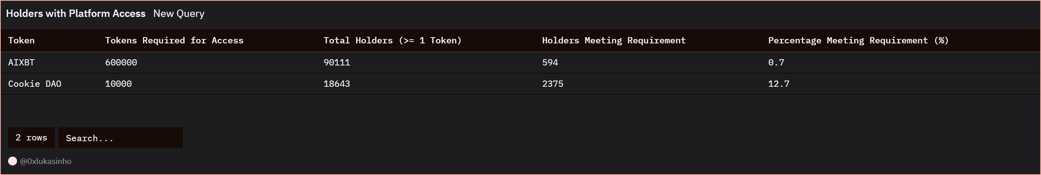
Looking at real-world examples, AIXBT's current state is telling. Only 0.7% of all token holders maintain the 600,000 tokens (valued around $300,000) required for terminal access. Given this prohibitive cost, AIXBT has essentially transformed into a pure meme coin - it's unlikely that there is anyone willing to purchase such large token amounts for platform access. Cookie DAO presents a more interesting case study. It’s also the platform that has the highest amount of holders that are premium users, indicating it is the product with the highest real demand.
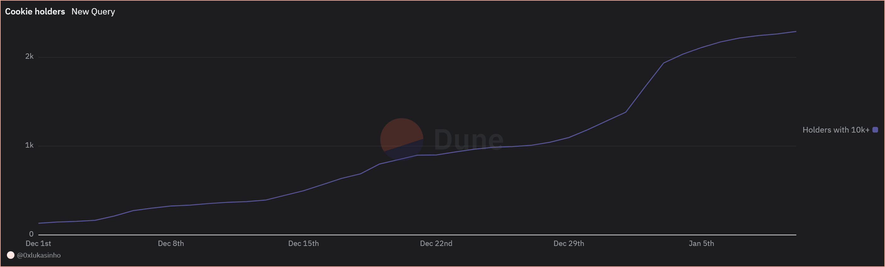
Their premium user growth shows steady upward momentum, indicating that even at higher prices there are still some traders willing to buy enough tokens to gain access to premium features. However, since January growth is now showing signs of stagnation.
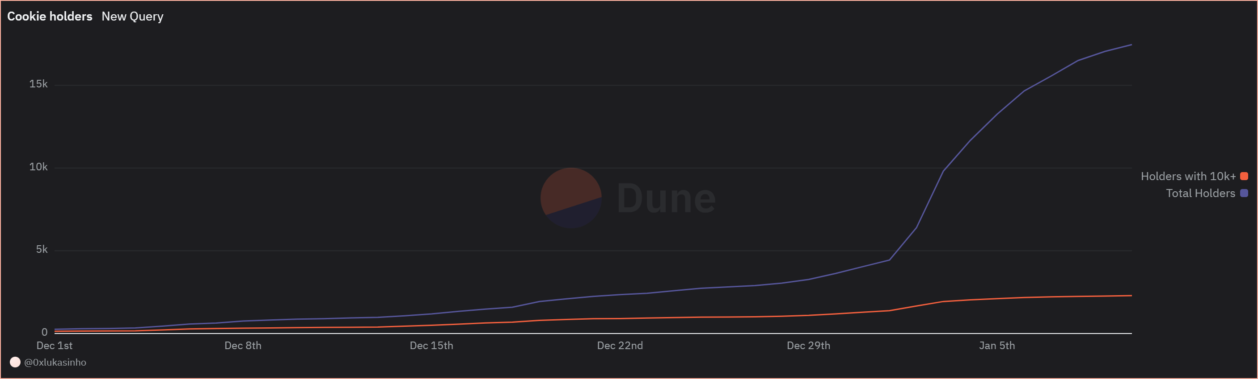
At the same time, the overall holder count embarked on exponential growth – indicating that the platform quickly gained mindshare and interest. In a traditional business, this would typically translate to accelerating sales. However, the token gating model creates an inverse effect: as platform interest grows, more speculators enter and token prices rise, genuinely interested users willing to pay for the service are priced out. This create a paradox dynamic were accelerated distribution leads to slower adoption of paying customers.
To address this challenge, teams could lower the threshold of tokens required for access. While this might trigger some selling pressure from access-focused holders and temporarily slow growth, it would help distribute tokens more widely among users, enhancing system sustainability. Alternatively, teams could introduce a hybrid model with a third tier, allowing users to choose between monthly fees or free access through token holdings above certain thresholds.
So, getting back to our initial question, is token gating a great growth hack and natural business model? Or is it an unsustainable model that will inevitably crash?
I guess this is yet to be seen. This is the first time we have genuinely useful platforms that could attract a large group of paying users opting for a token gated business model instead. But exactly that is where my doubts come in. Achieving widespread adoption becomes virtually impossible when there's a threshold that makes continued growth impossible. By token gating access these platforms might cap their growth and adoption, making the development of a sustainable business unnecessarily tough.
If platforms rigidly stick to their current model keeping the same threshold disregarding the effect of rising prices on user acquisition, I think there is a big opportunity for potential competitors. Anyone stepping in and offering a platform with the same features through more accessible subscriptions could take over market share effectively.
Another elephant in the room is long-term revenues for the developers. Maintaining platform development, introducing new features, and sustaining growth requires a steady stream of income. Initially, and while markets are bullish, token sales can fulfill this need. But eventually, companies developing consumer platforms need sustainable revenue streams. So, I think at some point, teams will be forced to introduce subscription tiers, or find another business model that offers recurring income.
Overall, despite some concerns about the long-term sustainability and viability of the token gating model, I'm very excited about these economic experiments and where they will lead us. I think it's a great model to get started and grow platforms quickly. Once they've reached product-market fit, teams still have plenty of time to develop sustainable business models that satisfy token holders while enabling continuous growth and reliable revenue streams. I’m excited to see how these platforms develop in the future.
Token gating vs subscription based
Main model we currently see employed by most agents and platform: AIXBT, cookie DAO, Polytrader. Simply so far it works, comes with many benefits. But is also an experiment. All these platforms could also work with a classic tried and true subscription based model. Pay monthly / yearly to receive premium feature instead of holding certain amount of token. Comes with its own set of advantages and disadvantages.
Opponents of token gating platforms will quickly point out that we did run this experiment already in the last cycle. Whereas holders of these coins will say it’s the best thing since sliced butter to shill their investment. I think the truth is a bit more nuanced. Yes, we had token gating experiences. But these were mostly private discord access or access to a pre-alpha game via NFT. Cookie DAO is different. This is the first time we have real platform, a great product people would probably pay subscriptions for that is token gated instead of charging a monthly fee. Yet, there are also valid concern around user acquisition and growth of such models.
So let’s dissect pros and cons first
Pro token gating:
- Very crypto native. Buy token, use for free while holding token. Great mechanism to gain early adopters in crypto space. Especially early when price is low.
- Pumps token price. People need to buy & hold
- Pumping token = best marketing
- Early Flywheel: More users = higher price = good marketing = more user. Until it breaks and platform gets very expensive, pricing out users. Talk more about this later. But early on definitely a great flywheel to quickly grow.
- Token launch and selling into market allows team to quickly raise funds. Easier than spinning up platform and find customers that pay like in subscription based model is necessary.
- Provides a floor for token price. If product is really useful, once price is cheap enough, there will be buyers that don’t care about price development but just want access to platform. So limits downside of token to a certain amount.
Downside:
- Hard to scale because hit growth ceiling. At some point platform so expensive new users are priced out. Only limited number of hardcore crypto degens willing to invest $10k+ to use an analytics platform. The long time of users is priced out. So there is an inherent ceiling.
- No recurring revenue for devs. Token are held not sold. Dev revenue comes only from selling treasury. Relying on stable token price or value go up. This becomes a challenge looking at long time frame.


Only 0.7 of all holders hold the 600’000 valued at around 300’000$ needed to have access to AIXBT’s terminal. No surprise considering how expensive it has become. At this point I’d consider AIXBT purely a meme coin. I heavily doubt anyone would really buy this amount of its coin to get access to the terminal. Hence Cookie DAO is probably more interesting case study for this analysis. It’s an amazing platform, many traders use it. Definitely traders that are willing to invest 6000$ into it to get premium access.

Looking at premium user growth we can generally see a steady trend up. So early buyers aren’t selling, or if they sell, they keep at least 10000 tokens to maintain premium access. And despite the relatively high price, we still have new traders buying tokens to get access to the platform. Though that growth seems to slowly stagnate since January.

Looking at the overall holder count, we can see that this has been growing quickly in January. So what this indicates is that mindshare and interest in the platform is growing. In a traditional business this would be when sales numbers really start to pick up. But for cookie DAO the opposite happens. As the platform gains more interest, price rises, more speculators buy in, further pushing price up. Platform access gets too expensive for many people, so growth of premium user slows down instead of accelerating once a certain threshold is reached.
To counteract this problem, the team could lower the amount of tokens necessary to get access. Sure, this might lead to a sell off from some holders that just care about the access, hence slow growth. But it would help with distributing the token among more users, making the system more sustainable. Alternatively the team could create a third tier, allowing users to decide if they want to pay a monthly fee or have access for free by holding tokens higher than a certain threshold.
So in the end, is token gating the natural business model in crypto and a great fit? Or is it an unsustainable model that will inevitably crash?
I guess we don’t know that yet. This is the first time we see genuinely useful platforms, that can attract a large amount of users being token gated. But exactly that is where my doubts come in. Getting to a large amount doesn’t work if there is a threshold that makes continued growth almost impossible.
Thus, if the model is kept rigid, with the same token threshold as only access to the paid features, no adjustment to account for the rising price of access, then there is a huge opening for someone to come in and offer these features at a much more accessible way through subscriptions.
Another elephant in the room is long-term revenues for the developers. To keep updating the platform, introducing new features and keep growing, a steady stream of revenue is necessary. Initially, and as long as markets are bullish, token sales can achieve that. But eventually companies that develop consumer platforms will need a sustainable revenue stream. So I think at some point, the teams will be forced to introduce a subscription tier anyway.
Overall, despite some concerns about long-term sustainability and viability of the token gating model, I’m very excited about such economic experiments and where they will lead us. I think it is a great model to get started and grow the platform quickly. Once it has reached product-market fit, the teams still have more than enough time to figure out good business models for the long-term that satisfy token holders but also allow the company to grow it’s user base continuously and get sustainable revenue streams.

1/ "Buy our token or you can't use our product"
This might be the most genius - or the most stupid - business model in crypto.
And it's taking over AI x Crypto platforms.
Here's why it could change everything (or fail spectacularly) 🧵
2/ This thread is based on my article about token gating [Link article]
2/ Many leading AI x Crypto projects have adopted token gating as business model. While showing early success and offering numerous benefits, it remains experimental with doubts about long-term sustainability. They could just as easily operate under classic subscription models.
3/ Critics point out we've run similar experiments in previous cycles. While true, they were primarily limited to private Discord groups or pre-alpha games. We saw token gating by crypto credit card providers, most famously Crypto.com, but that was about Ponzi-like rewards.
4/ Products like Cookie DAO, AIXBT, or Polytrader are vastly different. This is the first instance of genuinely valuable consumer platforms, ones many users would willingly pay subscriptions for, choosing token gating over traditional fee structures.
5/ The advantages are compelling:
- Crypto native approach - users buy tokens and get free access while holding them
- Drives token price appreciation through sustained buying/holding pressure
- Creates powerful early flywheel: more users = higher prices = marketing buzz = more users
- Quick fundraising via token sales
- Natural price floor
6/ But the challenges are severe:
- Growth ceiling - as tokens appreciate, entry costs become prohibitive
- Limited to crypto-natives willing to invest thousands
- No recurring revenue - users buy & hold rather than spend
- Developer income relies on treasury sales
- Heavy dependence on stable/appreciating token prices

7/ To assess real demand versus token price speculation and long-term model stability, let's look at token holder distribution.
But before, this thread is based on my latest substack post. Make sure to subscribe for free if you enjoy this type of analysis.
8/ Looking at AIXBT: Only 0.6% of holders maintain the 600,000 tokens ($400,000) required for terminal access. Given this prohibitive cost, it's unlikely anyone's buying such amounts for access. Stripped of utility, AIXBT is traded purely like a meme coin.
9/ Cookie DAO is more interesting - largest number and percentage of premium users, indicating highest real demand. Premium user growth shows steady upward momentum, even at higher prices. But since January's price surge, growth has been slowing.
9/ Their case shows a paradox: overall holder count embarked on exponential growth – indicating quick platform mindshare gains. In traditional business, this means accelerating sales. With token gating we see the opposite.
10/ As platform interest grows, more speculators enter and prices rise. Genuinely interested users get priced out, slowing premium user growth despite growing mindshare. A paradoxical dynamic where accelerated distribution leads to slower paying customer adoption.
11/ Solutions? Teams could lower token thresholds. While this might trigger selling pressure from access-focused holders and slow price appreciation, it would help distribute tokens more widely. Or introduce hybrid models with third tier - choose between fees or token holdings.
12/ Is token gating a great growth hack and natural crypto business model? Or an unsustainable model that will inevitably crash? This is yet to be seen - first time we have genuinely useful platforms opting for token gating instead.
13/ If platforms rigidly keep same thresholds despite rising prices' effect on user acquisition, competitors have a big opportunity. Anyone offering same features through more accessible means could effectively take market share.
14/ Another elephant in the room: dev revenues. Maintaining development, new features, and growth needs steady income. Token sales work in bull markets, but platforms need sustainable revenue streams eventually.
15/ Overall, despite concerns about long-term sustainability and viability of the token gating model, I'm excited about these economic experiments and where they will lead us. Token gating is a great model to get started and grow platforms quickly.
16/ But once platforms achieve product-market fit, teams will need to develop sustainable business models that satisfy token holders while enabling continuous growth and reliable revenue streams to ensure long-term success.
17/ What do you think? Is token gating the future of France or an experiment destined to fail? Let me know in the comments.
If you enjoyed this thread, make sure to like and retweet it. Thank you for your support.

